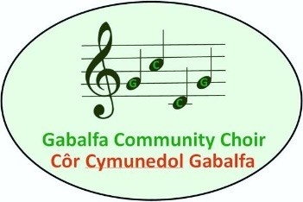

CHRISTMAS CONCERT
Presented by
GABALFA COMMUNITY CHOIR
Also featuring
YSGOL MYNYDD BYCHAN
FRIDAY 14TH DECEMBER 2018
ST MARK’S CHURCH
NORTH ROAD CF14 3BL
7:00 PM (Doors open 6:45)
Adults £5 (pay at the door)
Children attend free
Musical Director : Justine Oakley
Accompanist: Jeslyn Asir
Soloist: Freya Atkinson
Compére: John Brown
Refreshments and Raffle (After the performance)

